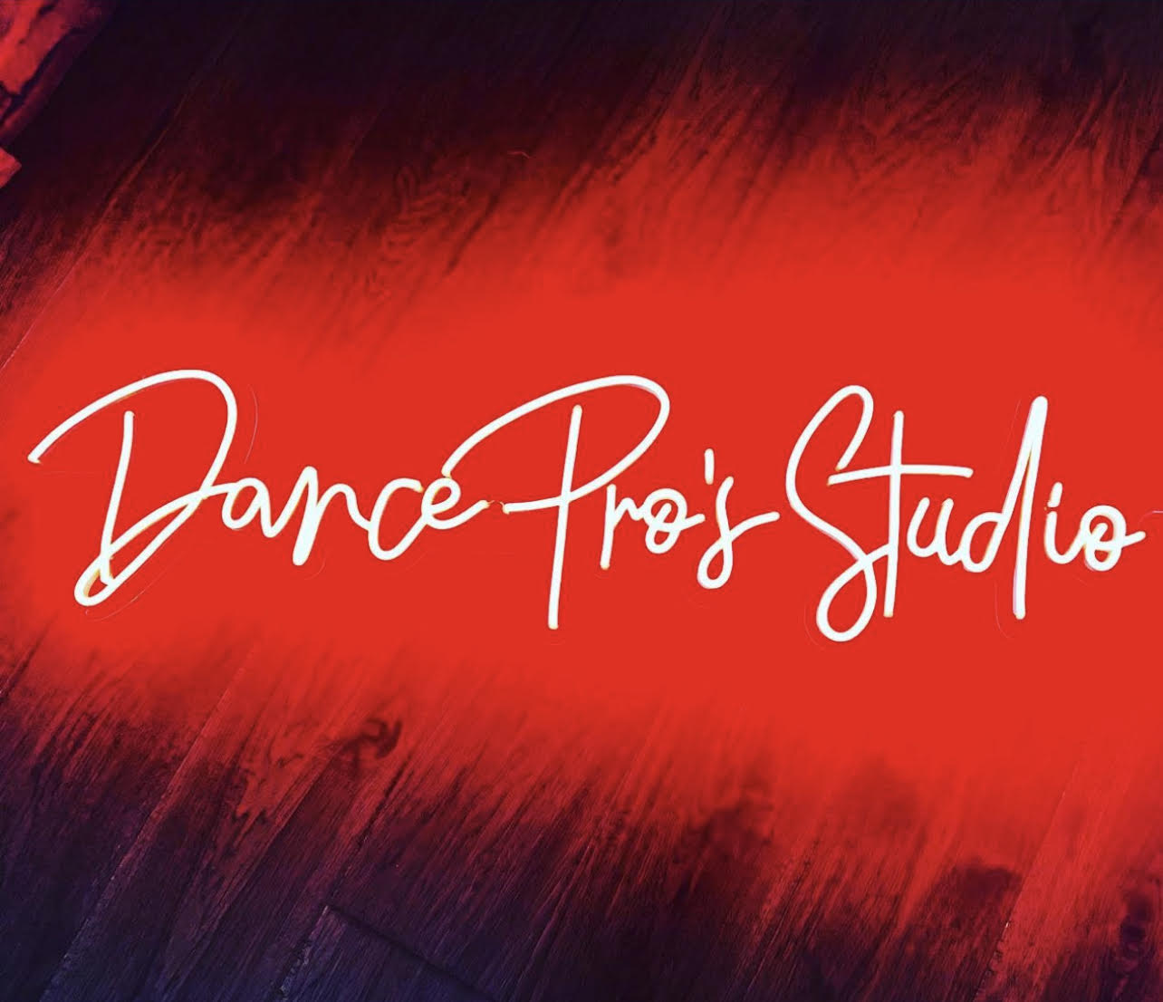

LET’S DANCE THIS SUMMER!!
Schedule for 2022 5 Week Summer Sessions

TUESDAY |  |  | WEDNESDAY |  | THURSDAY
 | Studio D  5:00-5:45pm  Princess  Ballet  Beginner  (5-7yrs)  5:45-6:30pm  Princess  Ballet  Intermediate  (5-7yrs)  6:30-7:30pm  Ballet  (Pre-Teen) | Studio P  4:45-5:45pm  Hip Hop  (Pre-Teen)  5:45-6:30pm  Princess  Hip Hop  Beginner  (5-7yrs)  6:30-7:30pm  Princess  Hip Hop  Intermediate  (5-7yrs) | Studio D  5:00-6:30pm  DPDC Training  Ballet  (Class Placement  Required)  6:30-8:00pm  DPDC Training  Ballet  (Class Placement  Required) | Studio P  5:00-6:30pm  DPDC Training  Jazz/Acro  (Class Placement  Required)  6:30-8:00pm  DPDC Training  Jazz/Acro  (Class Placement  Required) | Studio D  5:00-5:45pm  Princess  Jazz  Beginner  (5-7yrs)  5:45-6:30pm  Princess  Jazz  Intermediate  (5-7yrs)  7:00-8:00pm  Teen  Hip Hop  (12-Up) | Studio P  5:00-6:00pm  NCHS  6:00-7:00pm  Beginner  Acro/  Tumbling  (5-7yrs)  7:00-8:00pm  Beginner Acro/Tumbling  (Pre-Teen)

5 Week
Summer Session
(7/19 – 8/18)

Classes will be added as needed, based on enrollment.

DP Studios
125 Keystone Ave.
Bardstown, KY

Please Register
By
Phone

(502)203-2464
(502)827-4352

WE HOPE TO SEE YOU DANCING THIS SUMMER!

